Ideation Phase

Define the Problem Statements

|  |  |
| --- | --- |
| Date | 31 January 2025 |
| Team ID | LTVIP2025TMID40000 |
| Project Name | Enchanted Wings: Marvles of Butterfly Species |
| Maximum Marks | 2 Marks |

**Customer Problem Statement Template:**

Create a problem statement to understand your customer's point of view. The Customer Problem Statement template helps you focus on what matters to create experiences people will love.

A well-articulated customer problem statement allows you and your team to find the ideal solution for the challenges your customers face. Throughout the process, you’ll also be able to empathize with your customers, which helps you better understand how they perceive your product or service.

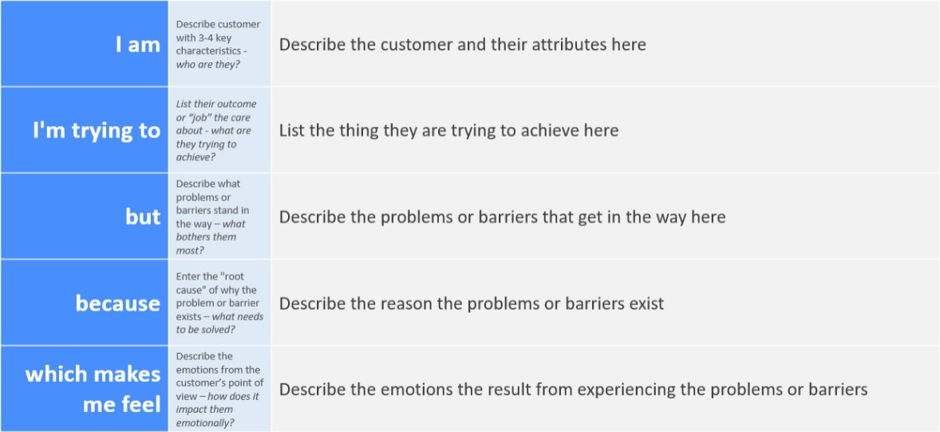

Reference: <https://miro.com/templates/customer-problem-statement/>

**Example:**

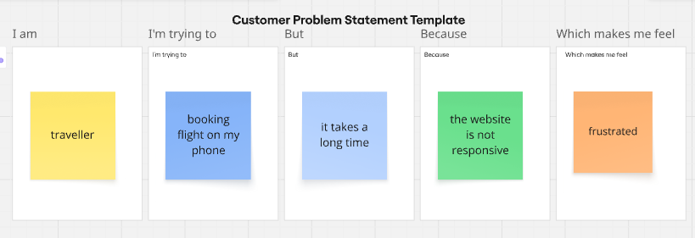

|  |  |  |  |  |  |
| --- | --- | --- | --- | --- | --- |
| **Problem**  **Statement (PS)** | **I am (Customer)** | **I’m trying to** | **But** | **Because** | **Which makes me feel** |
| PS-1 | A remote employee | Stay productive while working from home | My internet connection is unstable | My are has limited  Broadband options | frustrated and anxious about missing deadlines |
| PS-2 | A small business owner | Manage my inventory efficiently | I don’t have a centralized system | I am using manual  Spreadsheets that are error-prone | overwhelmed and worried about losing track of stock |